**Appendix 2**

To compare overwintering eastern and western populations, we used data from WWF Mexico (eastern) and Schultz et al. (2017) and the Xerces Society Thanksgiving monarch count (western). Eastern overwintering numbers are displayed as hectares occupied, with each hectare corresponding to approximately 21-28 million adults monarchs (Thogmartin et al. 2017a). We used simple linear regression to test for a correlation between eastern and western overwintering numbers within a given year and found only a weak positive correlation (R2 = 0.02, p = 0.41), shown in Figure 1B.

Based on an earlier analysis suggesting that western overwintering numbers may be correlated with the previous year’s eastern population (Vandenbosch 2007), we conducted a similar analysis, shown below in Figure S1. We also found that western overwintering numbers are significantly positively correlated with eastern overwintering numbers in the preceding year (R2 = 0.50, p < 0.001), consistent with Vandenbosch (2007). However, we note that this analysis is driven almost entirely by two years of high abundance in western North America (1996 and 1997) that also correspond to years with high uncertainty in overwintering estimates (Schultz et al. 2017). When these two years are omitted from analysis, the correlation is no longer significant (Figure S2). The positive correlation between eastern and western overwintering numbers (both within years and using a one-year time lag) may also reflect that both populations have declined over their monitoring periods, though likely for different underlying reasons (Pleasants and Oberhauser 2013, Thogmartin et al. 2017b, Agrawal and Inamine 2018, Crone et al. 2019).

**References**

1. Agrawal, A.A. & Inamine, H. (2018). Mechanisms behind the monarch’s decline. *Science*, 360, 1294–1296.
2. Crone, E.E., Pelton, E.M., Brown, L.M., Thomas, C.C. & Schultz, C.B. (2019). Why are monarch butterflies declining in the West? Understanding the importance of multiple correlated drivers. *Ecol. Appl.*, 29, e01975.
3. Pleasants, J.M. & Oberhauser, K.S. (2013). Milkweed loss in agricultural fields because of herbicide use: effect on the monarch butterfly population. *Insect Conserv. Divers.*, 6, 135–144.
4. Schultz, C.B., Brown, L.M., Pelton, E. & Crone, E.E. (2017). Citizen science monitoring demonstrates dramatic declines of monarch butterflies in western North America. *Biol. Conserv.*, 214, 343–346.
5. Thogmartin, W.E., Diffendorfer, J.E., López-Hoffman, L., Oberhauser, K., Pleasants, J., Semmens, B.X., *et al.* (2017a). Density estimates of monarch butterflies overwintering in central Mexico. *PeerJ*, 5, e3221.
6. Thogmartin, W.E., Wiederholt, R., Oberhauser, K., Drum, R.G., Diffendorfer, J.E., Altizer, S., *et al.* (2017). Monarch butterfly population decline in North America: identifying the threatening processes. *R Soc Open Sci*, 4, 170760.
7. Vandenbosch, R. (2007). What do monarch population time series tell us about eastern and western population mixing? *J. Lep. Soc.*, 61, 28-31.

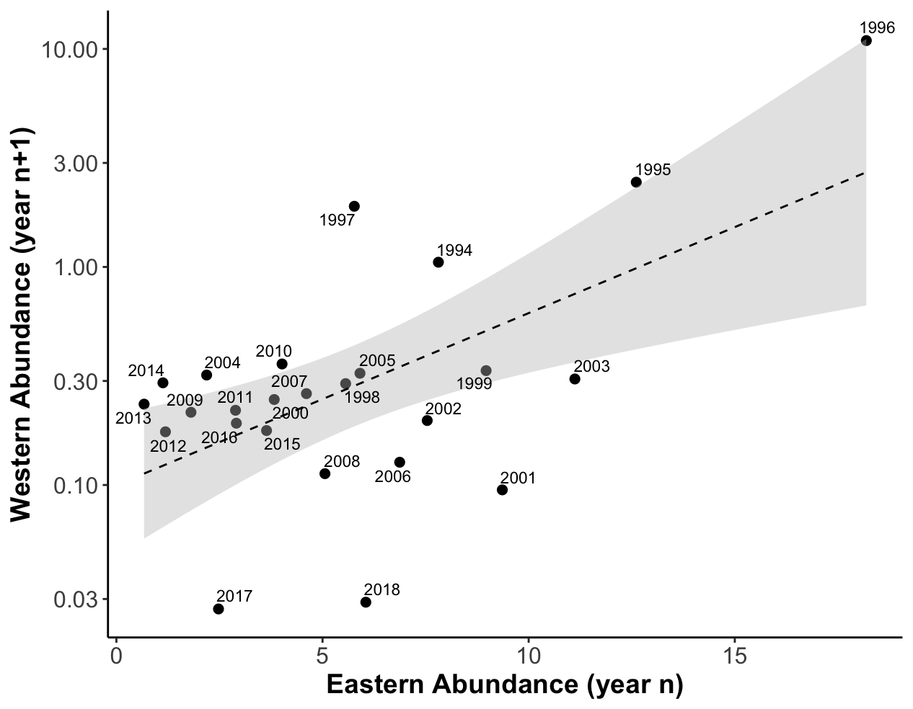

**Figure S1 –** When overwintering populations are plotted using a one-year time lag, eastern and western North American monarchs are strongly positively correlated (R2 = 0.50, p < 0.001). In the plot above, a given point corresponds to eastern overwintering abundance in a particular year, and the western overwintering abundance in the following year (e.g. the point labeled 2003 corresponds to the year 2003 in the east, and 2004 in the west).

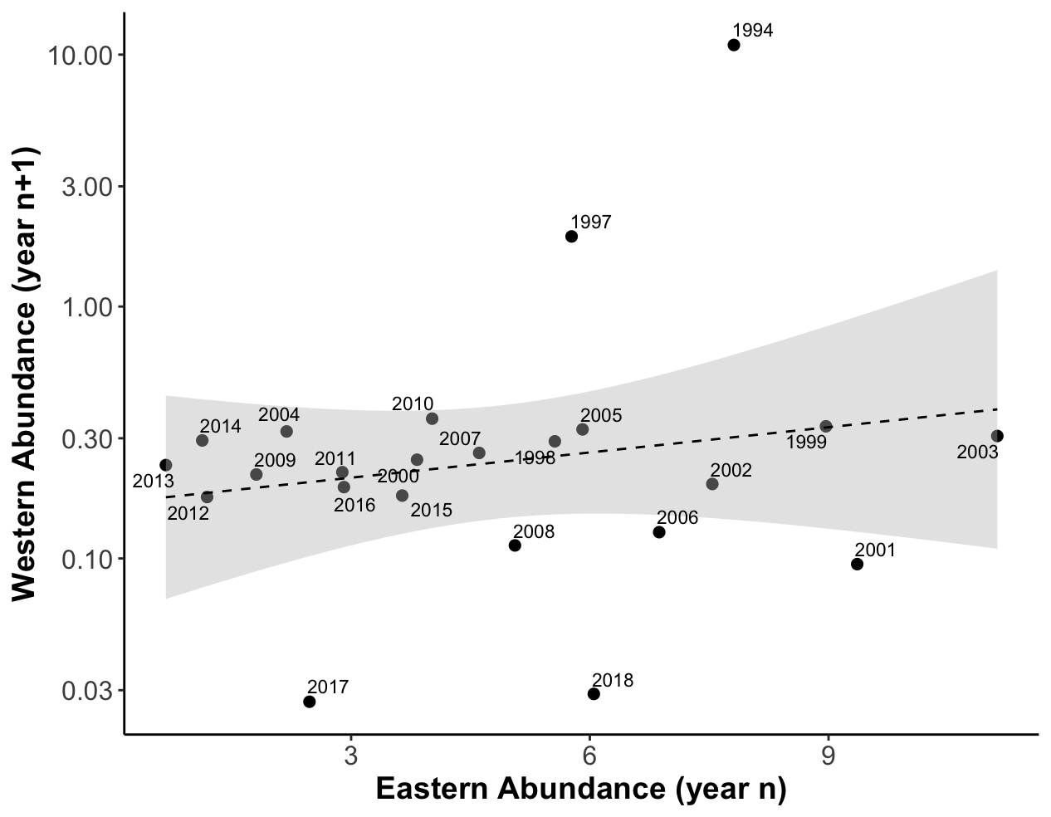

**Figure S2–** When two years (1995 and 1996 in the east, 1996 and 1997 in the west) are omitted from time series, the correlation between eastern and western overwintering numbers using a one year time lag is no longer significant (R2 = 0.06, p = 0.275).